Pokhara University

Level: Bachelor | Semester – Spring | Year : 2008
Programme: BE |  | Full Marks: 100
Course: Electronic Circuits |  | Time : 3hrs.

Candidates are required to give their answers in their own words as far as practicable.
The figures in the margin indicate full marks.

Attempt all the questions.

 | - Draw the small signal model of emitter follower amplifier and derive the expression for input and output impedance and voltage gain.  - Darlington pair can be regarded as a "super beta" transistor. Justify it. | 8  7
 | - Explain the effect of an Emitter Bypass Capacitor on low frequency response with necessary circuit diagram.  - "At higher frequencies, the gain of one amplifier reduce". Do you agree or disagree with this statement? Justify your answer.  - What is the basic principle behind push-pull Amplifier. Draw the circuit diagram of Transformer coupled load class B push pull amplifier and explain its operation. | 5  5  5
 | - What is efficiency? Derive the expression of the efficiency of direct coupled load class A amplifier.  - "Negative feedback improves signal to noise ratio". Justify it.  - Derive the expression of input impedance of the current series negative feedback configuration. | 5  5  5
 | - Explain Barkhausen criteria for oscillation. Design a Wien-bridge oscillator that oscillates at 25 KHz.  - Design an operational amplifier circuit that will produce an output equal to (-4v1 + 5v2 – 0.1v3) | 7  8
 | - Find the peak value of the output voltage of the ideal integrator shown in figure. The input is V_{in} = 1.0 sin (100t)V.  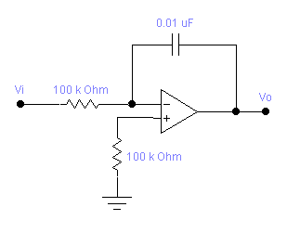  - Draw the basic circuit of log amplifier, and derive the expression for output voltage of this circuit. What are its drawbacks? How these drawbacks can be minimized? Explain. | 7  8
 | - What is the basic principle of A/D converter? Explain the flash A/D converter.  - Explain the R – 2R ladder D/A converter circuit. | 8  7
 | Write short notes on (Any Two)  - Regulated power supplies  - The Collpit Oscillator  - CMRR | 2×5

